24 Aug 2020 Rinoy Kuriyakose R3 56

Experiment:1

Program to find the smallest element in a Array

Program:

public class SecondSmallest {  
 public static void main(String[] args) {  
 int i, min,temp=0;  
 int[] arr = new int[]{998, 221, 233, 412, 425, 696, 567, 548, 99, 1000};  
 min = arr[0];  
 for (i = 1; i < 10; i++) {  
 if (min>arr[i]) {  
 temp = min;  
 min = arr[i];  
 }  
 }  
 System.out.println(temp);  
 }  
}

Output:

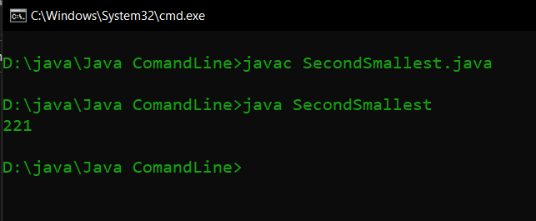

24 Aug 2020

Experiment:2

Program to check whether a given number is prime or not

Program:

public class PrimeNumber {  
 public static void main(String[] args) {  
 int x=23,i,n=0;  
 for (i=2;i<=x/2;i++)  
 {  
 if(x==0||x==1){  
 n=1;  
 }  
 else if (x%i==0){  
 n=1;  
 break;  
 }  
 }  
 if(n==0){  
 System.out.println("PRIME NUMBER");  
 }else{  
 System.out.println("NOT PRIME NUMBER");  
 }  
 }  
}

Output:

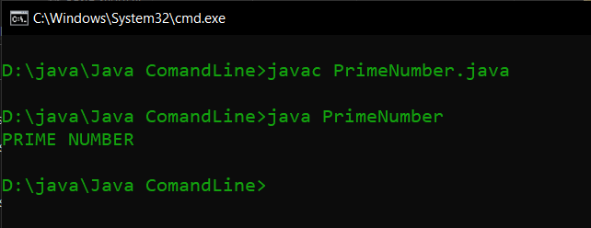

24 Aug 2020

Experiment:3

Program to Multiply two given matrices

Program:

public class MultiplyMatrix  
{  
 public static void main(String args[])  
 {  
 int arr1[][]={{1,2,3},{4,5,6},{7,8,9}};  
 int arr2[][]={{9,8,7},{6,5,4},{3,2,1}};  
 int multiply[][]=new int[3][3];  
   
 for(int i=0;i<3;i++){   
 for(int j=0;j<3;j++){   
 multiply[i][j]=0;  
 for(int k=0;k<3;k++){   
 multiply[i][j]+=arr1[i][k]\*arr2[k][j];  
 }  
 System.out.print(multiply[i][j]+" ");  
 }  
 System.out.println();  
 }   
 }  
}

Output:

